Salon Appointment System

A Major ProjectSynopsis Submitted to



Rajiv Gandhi Proudyogiki Vishwavidyalaya, Bhopal
Towards Partial Fulfillment for the Award of

Bachelor of Technology
(Computer Science and Engineering)

Submitted By
Mradul Saklecha-0827CS211153
Naman Raj Purohit-0827CS211155
Rishabh Rathore- 0827CS211194
Rishiraj Chhalotre- 0827CS211197

Under the Supervision of
Prof. Ritika Bhatt



Department of Computer Science and Engineering
Acropolis Institute of Technology & Research, Indore
Jan-June 2025

Introduction of the Project
The Salon Management System is a web and mobile-based application designed to simplify and automate the appointment booking process for salons. Many salons still rely on traditional methods such as phone calls and physical appointment books, leading to inefficiencies like double bookings, missed appointments, and difficulties in managing staff schedules. This project aims to resolve these challenges by providing a centralized digital platform where clients can easily book appointments online, while salon staff can efficiently manage bookings, client records, and staff schedules. By streamlining operations, the system enhances customer experience, improves workflow efficiency, and boosts overall business productivity.

Objective
The primary objective of this project is to develop a user-friendly and efficient online salon management system that streamlines appointment scheduling and enhances salon operations. The system will allow clients to view available time slots, book appointments, receive confirmations, and manage their bookings with ease.
For salon staff, the platform will provide essential tools to manage appointments, client profiles, staff schedules, services offered, and generate reports for better decision-making. By automating and optimizing the appointment process, this system aims to reduce administrative workload, minimize scheduling conflicts, and enhance customer satisfaction, ultimately improving overall business efficiency.

Scope
This project focuses on developing a React Native-based Salon Management App with a Node.js backend. The app will provide core functionalities such as appointment booking, client management, staff scheduling, and reporting. The system will include a user-friendly interface for clients to book appointments and a dashboard for salon staff to manage bookings, services, and availability. The initial phase will cover basic scheduling and client management, while future updates may introduce online payments, Hardware setup and integration with existing salon POS systems will not be included in this phase, ensuring a smooth and scalable implementation.

Study of Existing System

Existing System/Application | Problems Addressed | Advantages | Disadvantages | Gaps Identified
Bookeo | Online booking, scheduling | User-friendly interface, mobile app | Can be expensive for small businesses | Limited customization options
Square Appointments | Payment processing, scheduling | Integrated payments, easy setup | Limited reporting features | Lack of advanced scheduling options
Timely | Client management, scheduling | Comprehensive features, reporting | Can be complex to learn | Less intuitive UI compared to simpler apps
Acuity Scheduling | Automated scheduling, payments | Highly customizable, integrations | Can be overwhelming for basic needs | Price point might be high for smaller salons
Fresha | Free plan available, basic scheduling | Free option, easy to use | Limited features compared to paid options | May not be suitable for larger salons with complex needs

Project Description
The Salon Management App will be a React Native-based mobile application with a Node.js backend. Clients will be able to browse available services, check staff availability, and book appointments through a user-friendly interface. Salon staff will have access to a dedicated dashboard to manage appointments, client data, staff schedules, and services. A database will store all relevant information, including client details, staff availability, appointment records, and service offerings. The system will process appointment requests in real-time, cross-check them with staff availability, and either confirm or reject them. Confirmed bookings will be saved in the database and reflected in staff schedules.

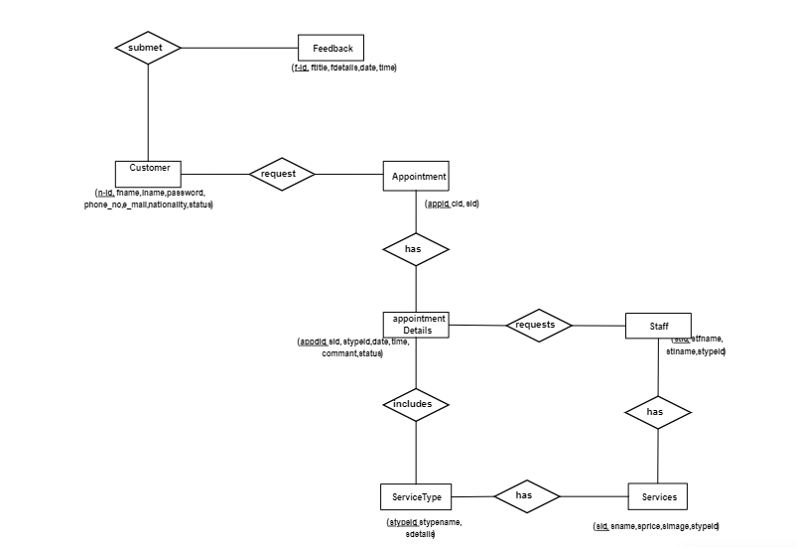
ER Diagram

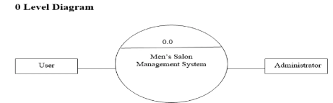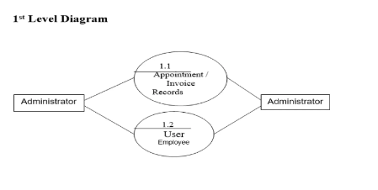

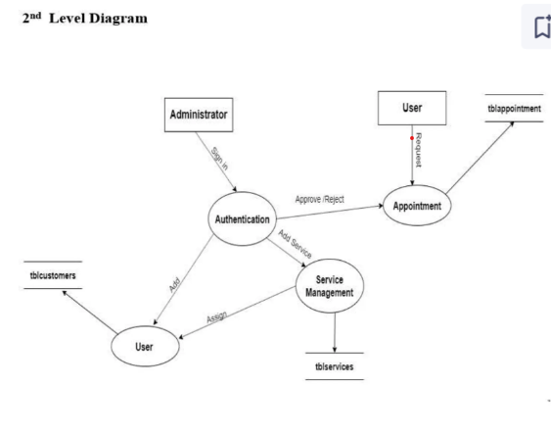

Planning of the Project work
The Salon Management App will be developed using an iterative approach with Agile methodology to ensure flexibility and adaptability throughout the project lifecycle. The project will begin with requirements gathering, where key features such as appointment booking, staff management, and user roles (clients, salon staff, and admin) will be identified. Once the requirements are finalized, the UI/UX design phase will focus on creating wireframes and intuitive interfaces to enhance the user experience.
Following the design phase, backend development using Node.js and database setup (MongoDB/PostgreSQL) will take place, ensuring a robust system for handling appointments, user authentication, and data management. Meanwhile, the frontend development using React Native will be carried out, allowing for the implementation of key features such as appointment booking for clients and a management dashboard for salon staff.
Once the core functionalities are developed, integration and testing will be conducted to ensure smooth communication between the frontend and backend. Unit testing and user testing will be performed to identify and fix any issues. Finally, in the deployment phase, the application will be launched on the Play Store and App Store, and user feedback will be gathered for future enhancements. This structured approach will help develop an efficient and user-friendly salon management system.

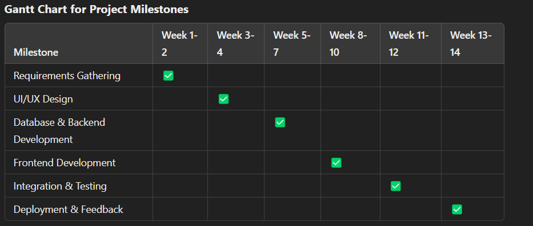

Features

User Interface Features:
- Intuitive UI/UX: Easy-to-use interface designed for both salon staff and clients.
- Responsive Design: Optimized for mobile (React Native) and web access.
- Real-Time Appointment Availability: Clients can check available time slots instantly.

Functional Features:
- Online Appointment Booking: Clients can book, reschedule, or cancel appointments.
- Client Profile Management: Clients can manage personal details, view booking history, and track upcoming appointments.
- Staff Scheduling: Salon staff can manage their working hours and track appointments.
- Service Management: Admin can add, edit, or remove salon services.
- Dashboard for Staff & Admin: Separate dashboards for appointment tracking, staff management, and reports.

Security Features:
- User Authentication: Secure login system with email/password or OTP verification.
- Data Encryption: Ensuring safe storage of client and staff information.
- Role-Based Access Control: Restricted access based on user roles (Admin, Staff, Client).

Performance Features:
- Fast and Optimized Performance: Efficient API calls and database queries for quick responses.
- Scalability: Supports multiple salons and users with ease.

Reporting & Analytics:
- Automated Reports: Generate reports on daily bookings, revenue, and staff performance.
- Business Insights: Helps salon owners track customer trends and optimize operations.

User Experience Enhancements:
- Notifications & Reminders: Automated email/SMS notifications for confirmations and reminders.
- Feedback System: Clients can rate services and provide feedback for improvements.

System architecture
Provide an overview of the system architecture. How will different components interact with each other? You can provide a high level diagram to understand the system.

User Interface (UI)
Describe the user interface design. You can include Form designs, wireframes or mockups if applicable.

Technology Stack

Frontend: (React Native - Mobile App Development)
- Framework: React Native
- Programming Language: JavaScript
- UI Library: React Native Paper / TailwindCSS
- State Management: Redux / Context API
- Navigation: React Navigation
- API Handling: Axios

Backend: (Node.js - Server-side Development)
- Runtime Environment: Node.js
- Framework: Express.js
- Authentication: JSON Web Token (JWT) for secure login
- API Architecture: RESTful APIs

Database: (Data Storage & Management)
- Database: MongoDB (NoSQL)

Cloud & Hosting: (Deployment & Storage)
- Backend Hosting: AWS / DigitalOcean / Heroku / Vercel
- Database Hosting: MongoDB Atlas (for MongoDB) / AWS RDS (for PostgreSQL)
- Storage Services: Firebase Storage / AWS S3 (for images & media)

Other Tools & Services: (Enhancements & Third-Party Integrations)

Push Notifications: Firebase Cloud Messaging (FCM)

Payment Integration (Future Scope): Stripe / Razorpay

SMS/Email Notifications: Twilio

Version Control: Git & GitHub

CI/CD: GitHub Actions

Testing Plan
The system will undergo rigorous testing to ensure functionality and reliability. Unit tests will be conducted to verify individual components. Integration tests will check the interaction between different modules. User acceptance testing (UAT) will be performed by potential users to validate the system's usability. Test cases will include scenarios like booking appointments, canceling appointments, managing staff schedules, and generating reports.

Here are some test cases for the Salon Appointment System, categorized for clarity:
I. Appointment Booking:
- Valid Booking:
  - Input: Select a service, staff member, date, and time. Provide valid client information.
  - Expected Result: Appointment booked successfully. Confirmation message displayed. Appointment appears in the salon's schedule and the client's booking history.
- Invalid Booking (Date/Time):
  - Input: Select a date in the past.
  - Expected Result: Error message displayed: "Cannot book appointments in the past."
  - Input: Select a time slot that is already booked.
  - Expected Result: Error message displayed: "Selected time slot is not available."
- Invalid Booking (Client Information):
  - Input: Provide incomplete or invalid client information (e.g., missing phone number, invalid email format).
  - Expected Result: Error message displayed: "Please provide valid client information."
- Booking with Special Requests:
  - Input: Include special requests in the booking (e.g., specific product, allergies).
  - Expected Result: Special requests are recorded and visible to the salon staff.
- Booking with Different Service Durations:
  - Input: Book services with varying durations.
  - Expected Result: Appointment schedule accurately reflects the duration of each service.

  - Input: Attempt to book an appointment that spans across two staff shifts.
  - Expected Result: System handles shift changes correctly.
II. Client Management:
- Creating a New Client Profile:
  - Input: Enter valid client information.
  - Expected Result: Client profile created successfully.
- Editing Client Profile:
  - Input: Modify existing client information.
  - Expected Result: Client profile updated successfully.
- Searching for a Client:
  - Input: Search for a client by name, phone number, or email.
  - Expected Result: Relevant client profiles are displayed.
- Viewing Client History:
  - Input: Access a client's appointment history.
  - Expected Result: Client's past and upcoming appointments are displayed.
III. Staff Scheduling:
- Creating Staff Schedule:
  - Input: Define staff working hours and days.
  - Expected Result: Staff schedule created successfully.
- Editing Staff Schedule:
  - Input: Modify existing staff schedule.
  - Expected Result: Staff schedule updated successfully.
- Viewing Staff Availability:
  - Input: View staff availability for a specific date.
  - Expected Result: Staff availability displayed correctly.
- Managing Staff Leave/Vacation:
  - Input: Record staff leave or vacation.
  - Expected Result: Staff unavailability reflected in the appointment schedule.
IV. Reporting:
- Generating Appointment Reports:
  - Input: Select date range for the report.
  - Expected Result: Appointment report generated successfully, showing details like client name, service, staff, and time.
- Generating Revenue Reports:
  - Input: Select date range for the report.
  - Expected Result: Revenue report generated, showing total revenue, revenue per service, etc.
- Generating Staff Performance Reports:
  - Input: Select date range and staff member.
  - Expected Result: Report shows the number of appointments handled by the staff member, revenue generated, etc.
V. Security:
- Login/Authentication:
  - Input: Enter valid username and password.
  - Expected Result: Successful login.
  - Input: Enter invalid username or password.
  - Expected Result: Error message displayed: "Invalid username or password."
- Authorization:
  - Input: Attempt to access admin functionalities with a regular user account.
  - Expected Result: Access denied.
- Data Security:
  - Input: Attempt to inject SQL code into input fields.
  - Expected Result: System should prevent SQL injection attacks.
VI. Performance:
- System Load:
  - Input: Simulate multiple users accessing the system simultaneously.
  - Expected Result: System should handle the load without performance degradation.
- Response Time:
  - Input: Perform various actions (e.g., booking, searching).
  - Expected Result: System should respond within an acceptable time frame.
VII. User Interface (UI):
- Responsiveness:
  - Input: Access the system on different devices (desktop, tablet, mobile).
  - Expected Result: UI should adapt to different screen sizes.
- Usability:
  - Input: Perform various tasks using the system.
  - Expected Result: System should be easy to navigate and use.

Expected Outcome
The successful completion of this project will result in a fully functional and user-friendly Salon Management App for both clients and salon staff. The system will allow clients to easily book, reschedule, and cancel appointments through an intuitive mobile interface. Salon staff will have access to a dashboard for managing appointments, client information, staff schedules, and services offered.
This app will eliminate the inefficiencies of manual appointment handling, such as double bookings and scheduling conflicts, leading to better time management and improved operational efficiency. Clients will benefit from the convenience of online booking, appointment reminders via SMS/email, and real-time availability updates.
For the salon business, the app will reduce administrative workload, minimize errors, improve customer retention, and ultimately boost revenue. The project will also serve as a learning experience in mobile app development using React Native, backend integration with Node.js, and database management with MongoDB/PostgreSQL.
In the future, additional features like online payments, loyalty programs, and integration with social media can further enhance the system, making it a comprehensive solution for salon management.

Resources and Limitations
Resources required for this project include a development environment (computer, software), internet access, and time. The project's limitations include the scope defined, which may not cover all possible salon management features. The project's success is also dependent on the chosen technologies and the development team's expertise.

Conclusion
The Salon Management App provides an efficient and modern solution to the challenges faced by salons in handling appointments and managing their daily operations. By leveraging React Native for the frontend and Node.js for the backend, the system ensures a seamless booking experience for clients and an organized workflow for salon staff. With features like real-time appointment scheduling, staff management, and automated reminders, the app enhances efficiency, reduces scheduling conflicts, and improves customer satisfaction.
This project not only simplifies appointment management but also minimizes administrative workload, enhances business productivity, and improves customer retention. The scalable architecture allows for future enhancements like online payments, loyalty programs. By successfully implementing this system, salons can transition from manual scheduling methods to a smart, digital solution, ensuring better service quality and business growth.

References
React Native Documentation – Official documentation for building cross-platform mobile applications.
- https://reactnative.dev/docs/getting-started
Node.js Documentation – Backend development resources and API references.
- https://nodejs.org/en/docs
Express.js Guide – Framework for building backend APIs.
- https://expressjs.com/en/guide/routing.html
MongoDB Documentation – Database management for storing client, staff, and appointment data.
- https://www.mongodb.com/docs/manual/
Firebase Documentation – Authentication and real-time notifications for bookings.
- https://firebase.google.com/docs
Redux Toolkit – State management for React Native applications.
- https://redux-toolkit.js.org/
React Navigation – Navigation handling in React Native applications.
- https://reactnavigation.org/docs/getting-started
Agile Development Methodologies – Agile principles for project planning and execution.
- https://www.agilealliance.org/agile101/
Salon Industry Reports – Insights into the digital transformation of the salon business.
- https://www.ibisworld.com/industry-statistics/

